**SLI3.0下安装fio测试**

SLI 3.0下载        <https://www.dell.com/support/home/us/en/4/Drivers/DriversDetails?driverId=C31J4>

SLI 3.0手册        <https://www.dell.com/support/home/us/en/04/product-support/product/supprt-live-image-v3.0/manuals>

Fio测试具体步骤:

1.Idrac挂载引导SLI3.0进入，配置好IP地址

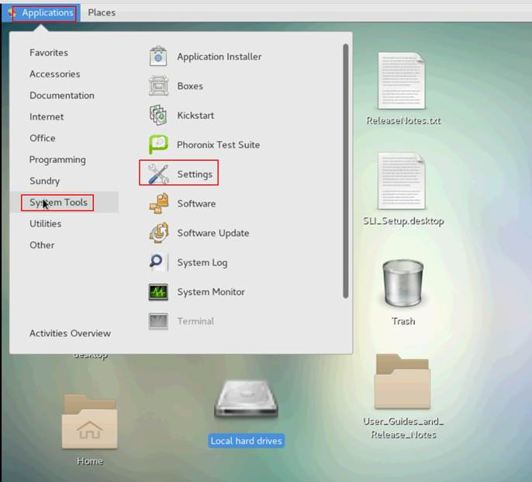

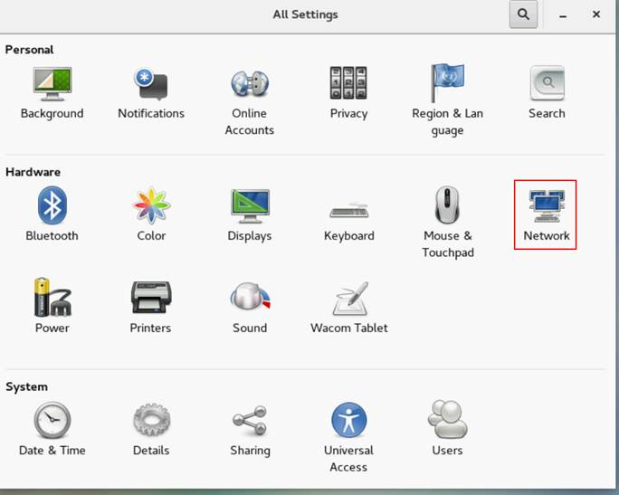

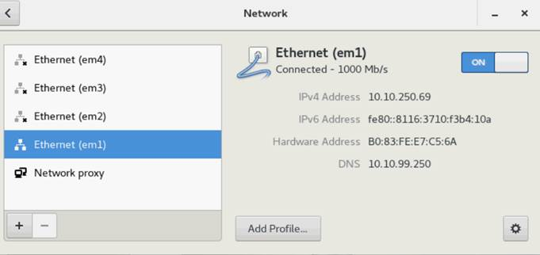

2.用SecureCRT或putty工具，SSH访问SLI3.0的IP地址,保存输出文本

SLI3.0用户名：root

密码：dell

用ftp工具(secureFX或是FileZilla ftp工具)上传fio安装包到/tmp目录

Fio工具下载：<https://ftp.emc.com/action/login?domain=ftp.emc.com&username=J9V5kmJi3&password=1B1i1vAA5i>

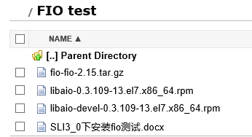

3.安装libaio插件和fio

[root@localhost ~]# cd /tmp

[root@localhost tmp]# ls

[root@localhost tmp]# rpm -ivh libaio-0.3.109-13.el7.x86_64.rpm

[root@localhost tmp]# rpm -ivh libaio-devel-0.3.109-13.el7.x86_64.rpm

[root@localhost tmp]# tar -xzvf fio-fio-2.15.tar.gz

[root@localhost tmp]# cd fio-fio-2.15/

[root@localhost fio-fio-2.15]#./configure

[root@localhost fio-fio-2.15]# make

[root@localhost fio-fio-2.15]# make install

4.测试举例：

[root@localhost fio-fio-2.15]# fio -filename=/dev/sdb -iodepth=16 -ioengine=libaio -direct=1 -rw=read -bs=2M -size=5g -numjobs=32-group_reporting -name=test-write

[root@localhost fio-fio-2.15]# fio -filename=/dev/sdb -iodepth=16 -ioengine=libaio -direct=1 -rw=read -bs=4k -size=5g -numjobs=32-group_reporting -name=test-write

注：/dev/sdb  请替换为客户的实际路径和文件夹，会影响对应盘符数据，请先备份好数据。

附：

FIO下载：<https://pkgs.org/download/fio>

FIO压力测试IOPS，相关参数说明

<https://blog.csdn.net/weiliu1463/article/details/31742061?depth_1-utm_source=distribute.pc_relevant.none-task-blog-BlogCommendFromBaidu-36&utm_source=distribute.pc_relevant.none-task-blog-BlogCommendFromBaidu-36>